**Author: George Kyeyune**

**Nnaggenda, Francis**

From an early age, Francis Nnaggenda knew he wanted to be an artist. Born in 1936, Nnaggenda was raised in rural Uganda where he became intimately connected with traditional life. He grieved over the way modernization was undermining the stability of African communities. Becoming an artist, he thought, was going to be the best and most practical way of raising his voice against a skewed development process that he was witnessing. With such strong opinions, Makerere Art School proved to be inconsistent with his aspirations. The School had at the time of the run up to independence abandoned the curriculum that was respectful of Ugandan art-making traditions which Margaret Trowell, its founder, had developed. Under Cecil Todd, Trowell’s successor (1958), Makerere Art School was instead reviewing its curriculum towards an emphasis on knowledge of world art, technique and skills acquisition. Elimo Njau and Sam Ntiro, Trowell’s direct and highly regarded protégés became Nnaggenda’s allies. The duo was opposed to Todd’s scholarly approach to art education and in the early 1960s, they prepared Nnaggenda for the daunting task of redefining traditional life along modern lines. In taking an alternative route in pursuit of an artistic career, Nnaggenda’s experiments in sculpture left an indelible mark on Uganda’s modern art landscape to which Makerere can lay no claim.

Nnaggenda pursued a French Diploma Course in Fine Art before seeking admission for a more robust training in sculpture in Germany (1964-1967). In Germany, he went through an apprenticeship system before he was formally admitted to Freiburg University, a highly competitive art academy. Freiburg offered a rigorous but flexible art training program but more importantly, it softened the ground for him to search for the essence of his ‘African spirit’. Ornamental arts, myths and legends abounded in Nnaggenda’s own cultural background, but, resonances of mask forms and masquerades were alive too in his consciousness. His own verbal and poetic, artistic environment, combined with emotional experiences allowed him to connect with the woodcarvings of West Africa. Nnaggenda believed that regardless of the vast distance separating the people of Africa, there was an underlying common characteristic all Africans shared and this formed the basis of an African intercultural cohesion. In his art, Nnaggenda adapted both the form and spirit in the mask objects he saw in German museums.

Upon completion of his studies in German, Nnaggenda returned home in 1967 and showed his sculptures and paintings at the Nommo gallery. The Kampala audience whose visual vocabulary had been colored by the work of Makerere Art School graduates where anatomy and color theory were of prime importance, were not ready for Nnaggenda’s innovations. The double face images and joining of metal and wood, for example, were unheard of yet in Kampala, though these were common practices elsewhere in the world.

In 1968, frustrated by Kampala’s inhospitality, Nnaggenda found a job in the neighboring Nairobi University in Kenya. The curriculum at Nairobi was more open than that of Makerere, even though Maloba, its new head had been a part of the Makerere staff since 1940. Furthermore, Nairobi had very little public art. This gave Nnaggenda the opportunity to make his mark. His large stone carving Mother and Child and a welded steel figure still grace the Kenya National Museum

So impactful was Nnaggenda’s art in Kenya that in 1995 he was invited to teach at Indiana University in the United States. He also had a residency in Texas before returning to Uganda in 1978, at the most inopportune time. The war that ousted Idi Amin was raging and Makerere (now Makerere University) was at its lowest point, occasioned by Amin’s repressive regime (1971-1979), which, among other atrocities, cracked down on the educated.

A civil war broke out two years after Amin’s exit which further constrained Makerere. Nnaggenda’s working style of recuperating materials helped to revive Makerere Art School when imported materials became scarce. He forged metals bars and made sculpture carving tools. The best known of Nnaggenda’s work is the War Victim. Fashioned from a single *Mukebu* tree trunk and realistically presented (1983-1988) War Victim is a robust sculpture of amputated mutilated body standing on one leg. It is a tribute to the resilient spirit of the people of Uganda. In 2001, Nnaggenda retired from teaching.

**References and Further reading**

Calder, A. (2000) “Uganda’s Modern Art Movement”, *Ijele.* Art Journal of the African World, Vol.1, No. 2.

Deliss**,** C. et al. (1995) *Seven Stories about Modern Art in Africa.* London: White Chapel Art Gallery.

Kingdon, J.  
-(1973) Makerere Art Gallery Catalogue. School of Fine Art Makerere University   
n.d: *Mkomazi Mind and Memory Maps* . Royal Geographical Society  
-(1962) “Reflections” *Transition.* Vol. 2, No. 6 and 7, October  
-(1995) “Makerere Art School”, Interview with Wanjiku Nyachae in Deliss *et al, Seven Stories about Modern Art in Africa.*

Kyeyune, G.  
-(2001) *L’art modern a l’university de Makerere Ouganda*, Antholgie de l’art Africain du Xxe Siecle. Editions Revue Noire, Paris, pp. 192-194.  
-(2002)*“Uganda’s Visual Environment”* in Action and Vision: Painting and Sculpture in Ethiopia, Kenya and Uganda from 1980. Edited by John Picton, E. Court and R. Loder, London: The Triangle Trust, pp 43-48.

Ntiro**,** S. (1960) ‘The future of East African Art’, *East African Cultural Heritage*. The East African Publishing House Ltd., Nairobi, Kenya.

Kasfir, S. L.(1999) *Contemporary African Art* , London: Thames and Hudson Ltd,

Sunanda,K. S. (2003) *The Local and Beyond: Francis Nnaggenda’s Sculptural Innovations*, Nka: Journal of Contemporary African Art, No 18, Spring/Summer, 2003, pp. 76-79,.

**Unpublished Literature**

Kyeyune, G.(2003) *Art in Uganda in the 20th Century***:** PhD thesis, School of Oriental and African Studies University of London

Sunanda, S.(2000) *Imaging Art, Making History: Two Generations of Makerere Art*, PhD thesis Emory University, Atlanta-Georgia

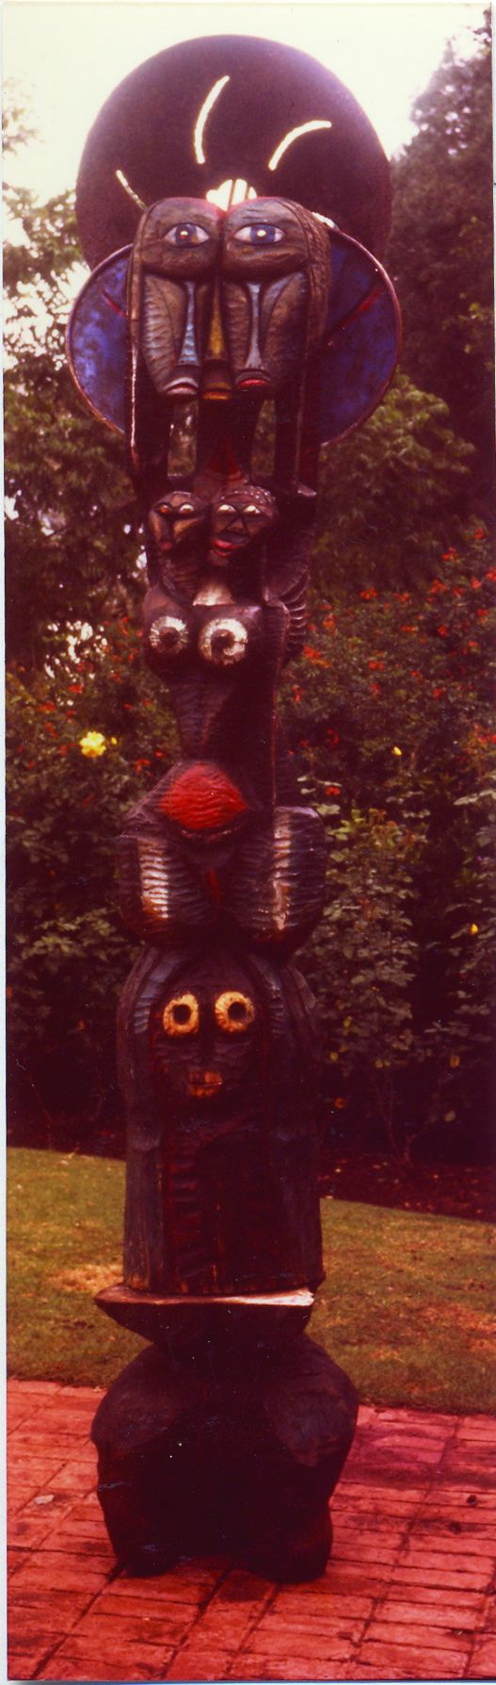

*Spirit Within Man*-- mixed media early 1970s, height 12 feet, Photo copyright Francis Nnaggenda (Photo taken in the early 1970s)

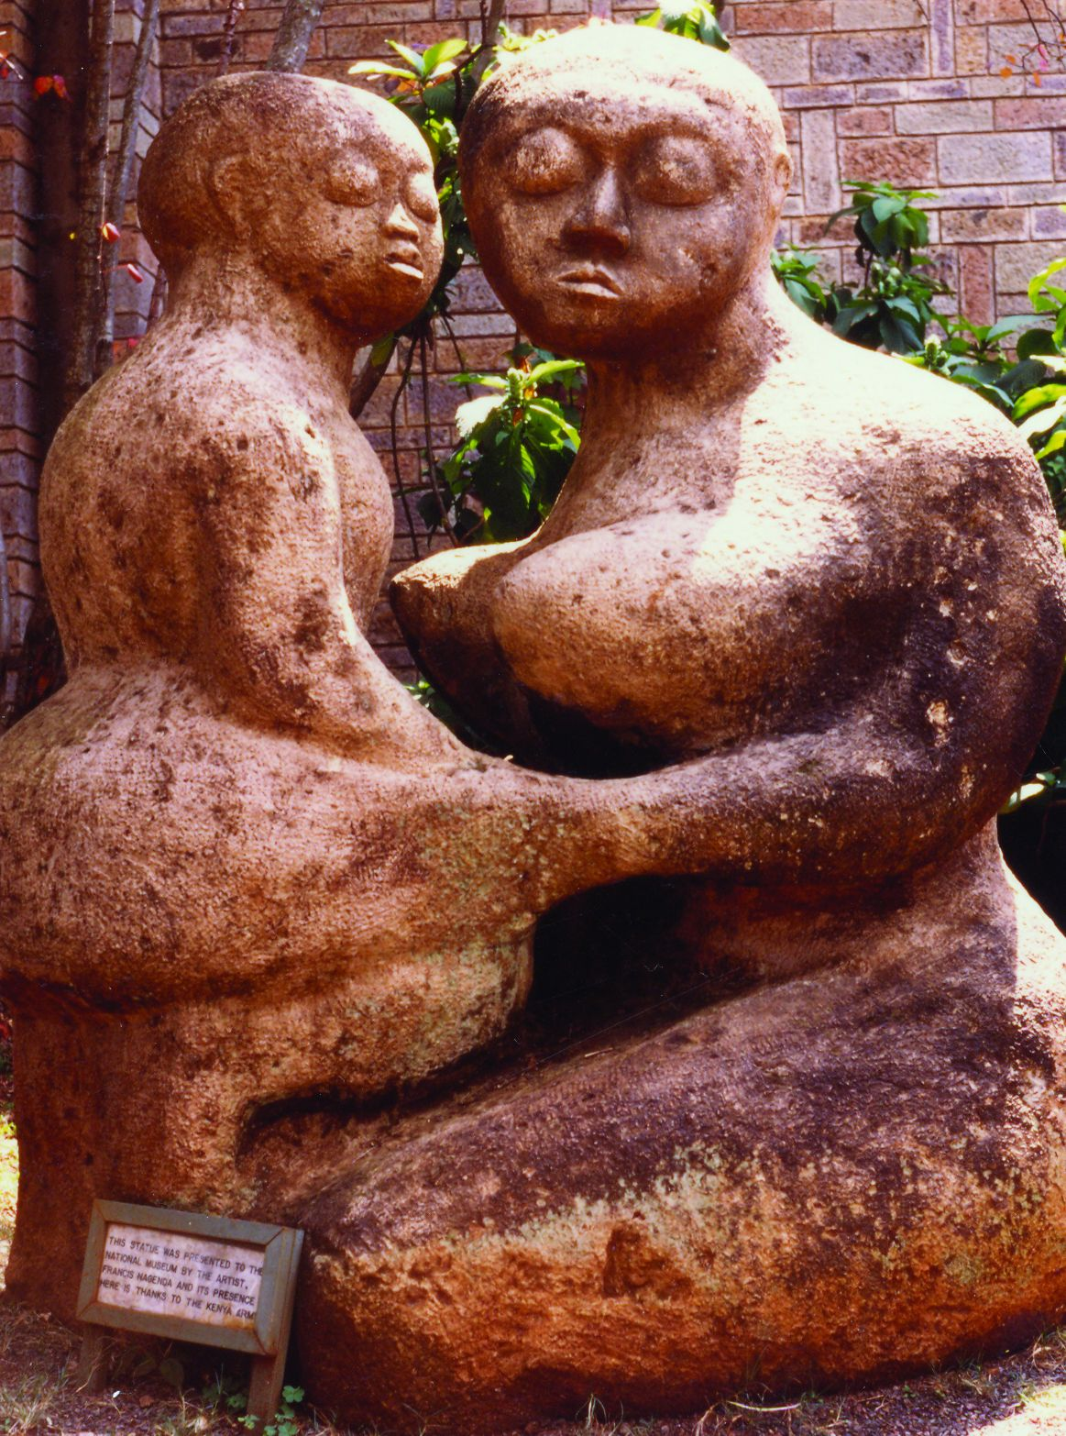

*Mother and Child*, Stone, early 1970s, 6 ft high. Photo copyright George Kyeyune (photo taken in 2002)

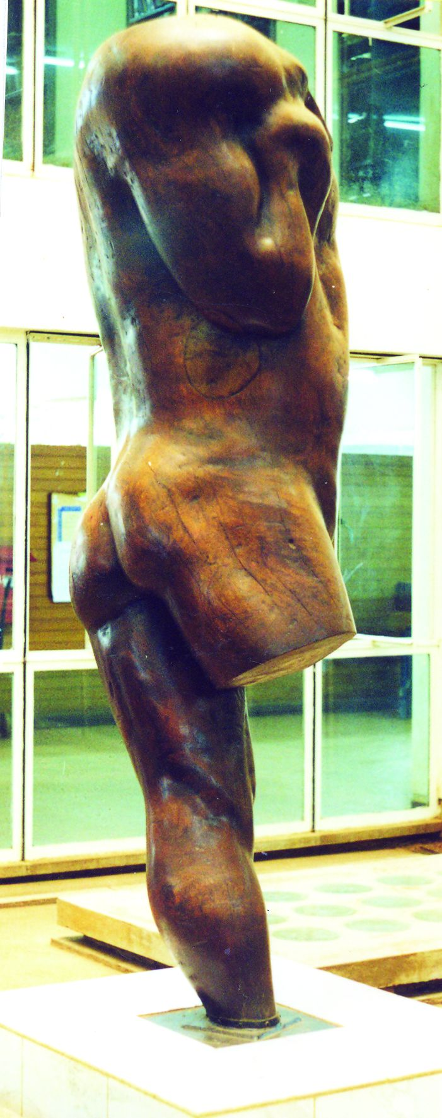

*War Victim* 9 ft high. Photo copyright George Kyeyune (Photo taken in 2002)